高博国际学院
外国留学生管理手册

目录
出勤与缺勤 4
奖学金、考试与作业 5
学生品行 6
教室通用规则与条例 7
考试规则 7
教务教学平台SeED 8
考试结果发布与访问 10
模块评估—学生在SeED平台上的反馈 13
作业提交 16
成绩评估标准 17
晋级到下一阶段的奖项 17
挂科后果 18
补偿机制（仅适用于SU项目） 19
学术不端行为 20
特殊情况 21
等级计算方法 23
资源室与独墅湖图书馆 26
学生社团执行委员会（SCEC） 27
住宿 31
健康保险 33
签证与居留许可（仅限外国留学生） 34
附录 34

The General Regulations for Students are made by the Academic Board of GIST-SU and shall take effect from 14 March 2016. The Regulations should be read in conjunction with the University’s Regulations for Academic Awards at
http://www.staffs.ac.uk/legal/policies/index.jsp#academicawdregs

When you first register with the College, you will be given a SeED account and required to provide an email address. The University will use SeED to post notices for all students. All invoices, reminder letters and statements will be sent to the email account you provided. It is your responsibility to check your e-mail and SeED daily and delete old email messages on a regular basis. Failure to do so may result in you being unable to access important messages. If you are on placement you should arrange to check your e-mail at least once per week. Failure on your part to do so will not constitute grounds for appeal or complaint.

Content
Attendance and Absence 3
Awards, Examination and Assessment 4
Student Conduct 5
Classrooms General Rules and Regulations 6
Examination Rules 6
SeED 7
Exam Results Releasing & Accessing 9
Module Evaluation - Student Feedback at SeED 12
Assignment Submission 15
How is my work assessed? 16
Progression to the next level of your Award 16
What if I fail a module? 17
Compensation (SU programme ONLY) 18
Academic Misconduct 19
Extenuating Circumstance 20
How do I work out which Classification I will receive? 22
Resource Room & DuShu Lake Library 25
Student Club Executive Committee (SCEC) 26
Accommodation 30
Health Insurance 32
Visa and Residence Permit (International Students ONLY) 33
Appendixes 33

The General Regulations for Students are made by the Academic Board of GIST-SU and shall take effect from 14 March 2016. The Regulations should be read in conjunction with the University’s Regulations for Academic Awards at
http://www.staffs.ac.uk/legal/policies/index.jsp#academicawdregs

When you first register with the College, you will be given a SeED account and required to provide an email address. The University will use SeED to post notices for all students. All invoices, reminder letters and statements will be sent to the email account you provided. It is your responsibility to check your e-mail and SeED daily and delete old email messages on a regular basis. Failure to do so may result in you being unable to access important messages. If you are on placement you should arrange to check your e-mail at least once per week. Failure on your part to do so will not constitute grounds for appeal or complaint.

Attendance and Absence

Attendance for all formal teaching is compulsory. On some occasions for reasons due to an illness or accident, your absence may be unavoidable. All absences must be notified to the relevant Tutor or Faculty/School Office immediately. Please refer to the end of this document for contact details.
In the case of absence due to an illness for a period, full-time students must complete a Leaving Application Form (see Appendix A) and submit it to the Student Service Office. Extended period of absence due to an illness have to be covered by a sick note from your doctor. In this case you might need to claim Extenuating Circumstances (see below) in relation to your learning and assessment. Your doctor's note will be a key piece of evidence required by the Extenuating Circumstances Panel considering your claim.
The University needs to satisfy itself that you are engaged in your studies and will monitor your attendance at regular intervals. This is a particular requirement for international students and applies equally to all students.
We recognise that there may be times when you are unable to complete work due to circumstances beyond your control. If you find yourself in such a position you can make a claim for Extenuating Circumstances. If in doubt, check with the Information Points or the Students' Union.
New Attendance Regulations – Applicable from Spring 2016 Semester Onwards
  - If you are more than 5 minutes late for a particular lesson, you will be noted as absent for the hour of lesson.
  - Should there be a break given by the teacher and you do not return within 15 minutes from the start of the break time, you will be noted as absent for the hour of lesson.
  - Should you miss more than 10% of the total lessons for a particular module, your assigned school counselor will warn you.
  - Should you miss more than 20% of the total lessons for a particular module, your assigned school counselor will warn you again and contact your parents. In addition, Student Service Office will issue a warning letter to you and your parents, which you will need to sign-off.
  - Should you miss more than 30% (exclusive), you will be withdrawn from the module as being “unengaged”. In such a situation, you will have to retake the module by attending classes for one more semester and paying the appropriate tuition fee.
  - Unless there is valid proof of major illness and/or other extenuating circumstances, all other reasons for being absent will be excluded from consideration when withdrawing you from the module. Minor illness (e.g. flu, period cramps, stomachache etc.), attending weddings, going on vacation etc. will not be considered as reasons for being absent.
The College reserves the right to intermit (interrupt) or withdraw your registration if your continued absence (unless authorised by the University) in the view of your Faculty, compromises your ability to progress/complete your course satisfactorily and/or meet the learning outcomes of the module(s) you are registered on.

Awards, Examination and Assessment
Students who complete satisfactorily the prescribed course of study and satisfy the appropriate Assessment / Award Board will receive the appropriate award of the University and/or be recommended for admission to the relevant external body.
Awards shall be deferred by the University until you have completed any legitimate outstanding requirement of the University or its partner institution, which includes payment of outstanding tuition fee.
If your academic progress or attendance is unsatisfactory, you will not be allowed to progress on your course of study and may be withdrawn from the University in accordance with the procedures, approved from time to time by the Academic Board, and outlined in the University’s Academic Awards Regulations.
You shall observe the Staffordshire University’s Examinations Regulations – Instructions to Candidates, approved from time to time by the Academic Board, and set out at
http://www.staffs.ac.uk/assets/gen_regs_app2_tcm44-26812.pdf
You shall observe the University’s Regulations on Academic Misconduct (applies to all programmes), approved from time to time by the Academic Board, and set out at
http://www.staffs.ac.uk/assets/academic_misconduct_tcm44-26770.pdf
You are responsible for the submission of your entries to the examinations of external bodies and special examinations, and must comply with any specific examination or other regulations of such bodies.
Examination Scripts will remain the property of the University and will not be made available or returned to students, and if seen by students after an examination for the purpose of feedback, will be collected immediately afterwards or accordingly students have an obligation to return those examination scripts.
You will receive feedback on your coursework and class test summative assessments, normally within 20 working days, following the coursework submission date or date of the class test. However, for a small number of modules, it may be the case that feedback within 20 days cannot be met for justified reasons (for example, modules on which very large numbers of students are enrolled). In those cases, the feedback period shall not exceed 25 working days. The anticipated feedback period for all assessments will be published in your Module handbooks.
In order to ensure that feedback is provided within 20 days, in some cases, the marks for your work shall be provisional and subject to final ratification by the appropriate Assessment Board in due course. It is your responsibility to collect feedback from your module tutor as soon as it is available.

Student Conduct
At all times you are expected to behave in a courteous manner to staff and fellow students. You are expected to attend your programme of study regularly and punctually when required to do so, co-operate with staff in the keeping of class registers and submit prepared work as and when required.
The possession and/or use of illegal drugs and abuse of intoxicating substances, including legal highs, on University premises is strictly forbidden.
The possession and/or use of firearms or other offensive weapons (including replicas) on University premises is strictly forbidden.
For reasons of health, safety and hygiene, smoking is not permitted within the University other than in certain areas under the control of the Students’ Union in accordance with current UK legislation.
Food and drink may be consumed only in authorised areas and not in classrooms, IT areas or specialist laboratories unless permission has been given to do so for documented medical reasons. Hot food is not allowed in the libraries.
You may not sell goods or services on University premises other than areas under the control of the Students’ Union without the prior approval of the College.
Any form of gambling on University premises is strictly forbidden other than in areas under the control of the Students’ Union.
At all times you are expected to conduct yourself in a reasonable and orderly manner with due regard to other people and their property.
You must not wilfully engage in conduct which prevents, obstructs or disrupts the holding or orderly conduct of any meeting or other lawful assembly in the University or which amounts to an unreasonable interference with the University’s ability to conduct its business, such as the provision of academic and related services and/or commercial activities.
The University takes all cases of breaches of disciplinary procedures seriously and has the right to take appropriate action against those students who breach them. If you are accused of breaching these regulations, you are strongly recommended to seek advice and support from the Students’ Union’s Student Advice Centre for help to prepare your case.

Classrooms General Rules and Regulations
When in the classroom:
- Strictly no smoking or eating.
- No playing card games or any other games.
- Students must be decently dressed and conduct themselves properly at all times.
- Please be considerate and keep noise to the minimum in the classroom even when there is no lesson being conducted. Loud noises from you will disrupt neighboring classrooms where lessons may be conducted.
When leaving the classroom:
- Any empty bottles, cans or garbage must be properly discarded.
- Please ensure the desks and chairs are in order.
- Please turn off the lights, projectors and air-conditioners.
- Please do not leave any valuables in the classroom unattended. The College is not responsible for damages or theft of your valuables.
The classroom is only opened to the students and staff of GIST International College (GIC). Strictly no outsiders are allowed without prior written consent from the management.
Should you breach any of the above rules, the teachers shall, at their discretion, submit a Student Misconduct Report to the Academic Office. This report will be reviewed during Exam Board Meetings with the relevant partner university and may thus affect your grades. The teacher may also confiscate your offending article and only return it to you at the end of the day.
Students who fail in their assessments may be offered a referral at the discretion of the Exam Board.
Students who need to retake the module by attending classes will need to pay the appropriate tuition fee for that particular module.
Plagiarism, collusion and cheating during tests/exams are very serious offences in which students will immediately obtain zero for the offending assessments (see Academic Misconduct).

Examination Rules
- Preferably arrive fifteen (15) minutes before the start of the exam. Any student who arrives after the start of the exam will still be admitted for first thirty (30) minutes. Thereafter students will no longer be allowed into the exam venue.
- Leave items such as bags, jackets and electronic devices which are not required for the exam at the front of the exam venue.
- Each student must display his/her student ID card on his/her desk. Students with incomplete or inconsistent identification will not be allowed to take the exam.
- No dictionaries (electronic or otherwise), mobile phones or other electronic devices are allowed with students during the exam. They are to be turned off and put at the front of the exam venue. After the exam is over, students may collect their belongings before leaving the venue. Should any of these devices be found on a student, especially if the mobile phone rings, it will be treated as an Academic Dishonesty case in which the invigilator will then fill in a memo.
- For open-book exams, students may enter the venue with the necessary stationery including books and notes that have been approved by the module teacher. Students are not allowed to borrow stationery from another student when the examination is in progress but may do so via the invigilators.
- Do not open or turn over the exam paper until being instructed by the invigilators. Students may read the cover page though.
- Any student caught letting other nearby students see his/her exam paper or answer script will be deemed guilty in helping other students to cheat. A memo on Academic Dishonesty will then be filled by the invigilators.
- Students will be subjected to strict disciplinary action by the College if they are found cheating in any quiz, test and examination. The student has the right to appeal to the Disciplinary Committee.
- During an exam, students are not allowed to leave the venue without being accompanied by an invigilator. A student who does so will no longer be admitted back to the venue. Please go to the washroom prior to the exam.
- Students will be permitted to leave the exam venue after the first sixty (60) minutes has elapsed but will not be permitted to leave during the final thirty (30) minutes. Leave the venue quietly as there will be other students who are still attempting the exam.
- Stop writing immediately at the end of the exam time.
- Leave all papers on the desk to be collected by the invigilators. This includes the question paper and any rough notes and/or drafts.
- Wait until the invigilators have collected all the papers before leaving the venue quietly as there may be other examinations taking place nearby.

SeED
What is SeED?
SeED is an online 'Virtual Learning Environment' where you can explore, discuss and learn about your chosen subject. You have direct access to your academic lecturers, the learning support staff and your student peers. You can connect to SeED from any computer/mobile devices with internet access.
SeED will play an important role in your studies when you become a GIST International College student. SeED provides online access to course materials and learning resources. You will also be able to:
  - Receive important notices from the College
  - Access to important reference materials, handouts, reading lists and web links
  - Talk to other students and tutors through online discussion boards and forums
  - Discuss ideas, exchange information and join in lively debates
  - Complete and submitt your assignments with the support of online marking and feedback
  - Keep up-to-date with course deadlines and announcements
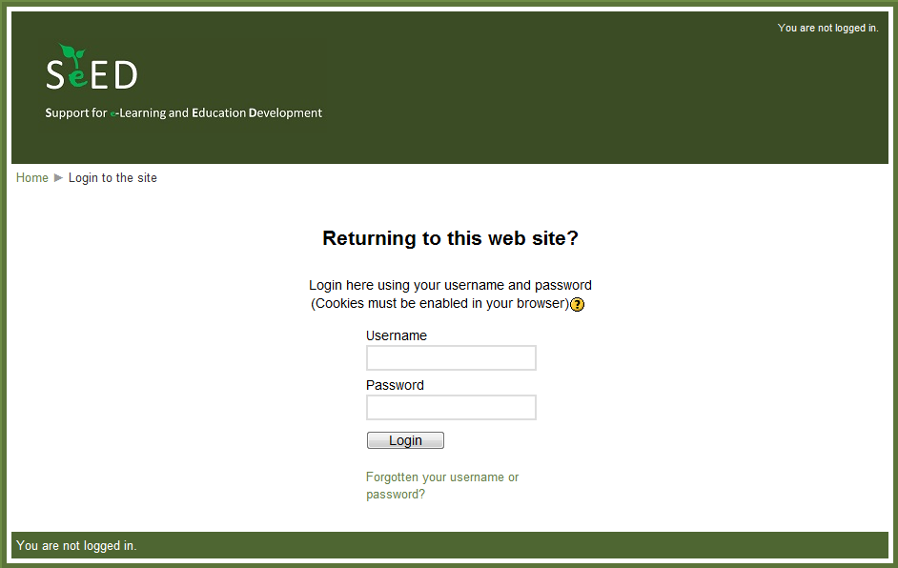
To access SeED, you can log on to http://seed.gist-edu.cn
Then enter your username and password as follow:
Username: <student ID>
Password: <last 6 digits of IC / passport> + “@gic”
For example, if your student ID is 1203-1-099 and passport number is A56785432 then you should enter:
Username: 12031099
Password: 785432@gic
Update Your Profile on SeED
All students MUST update your profile with the correct Student ID number, valid email address and contact phone number on SeED so that you can be notified (i.e. exam results, referral dates, invoices, etc.) in a prompt and effective manner especially during the holidays. Students who fail to update his/her profile will not be able to receive the final exam results for each module!
All students are responsible for providing their correct contacts. Any excuse of not receiving emails from the College or not being able to access SeED is unacceptable. Please check SeED and your emails regularly during the holidays for important notices.
Please refer to the following steps to complete your profile on SeED:
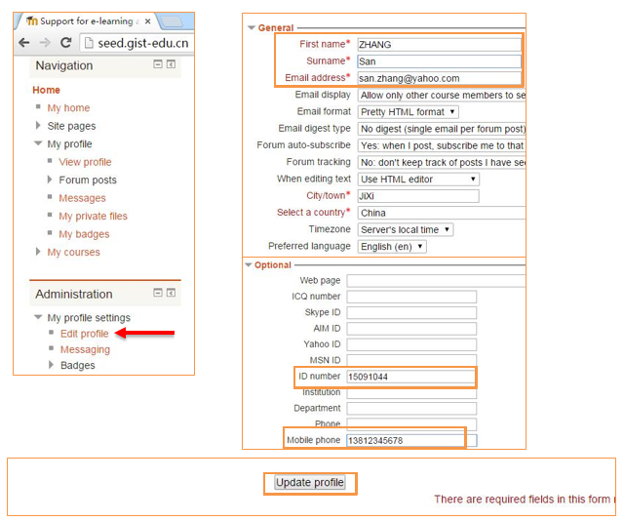

Exam Results Releasing & Accessing
After the Final Exam is completed, it will usually take about two (2) weeks for the teachers to mark the exam papers and for the Academic Office to tabulate the results. Thereafter the results and answer scripts will be sent to Partnerships for review. It will usually take another week or two to review the materials before a board meeting is held between Partnership and the College. The College can only release your results after the board meeting. Therefore the turnaround time between the Final Exam and the release of the results may take about four (4) to five (5) weeks. This is the standard procedure. The release of exam results can only be officially carried out by the Exam Unit. No other party is allowed to release results to the students.
Academic Office will release all students’ exam results via SeED ONLY. If you did not receive your results during the school holiday, please contact Ms. Anne WANG (refer to Contacts) from Exam Unit or send a private message to Academic Office on SeED. It is the student’s responsibility to ensure the student profile (i.e. email address and Student ID) is correct. Students are also encouraged to check SeED regularly during the holidays for important notices.
Follow these steps to access your final exam results on SeED:
Step One: Log on to SeED then go to “My courses”.
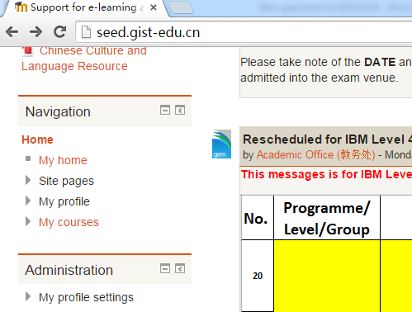

Step Two: Select your module.
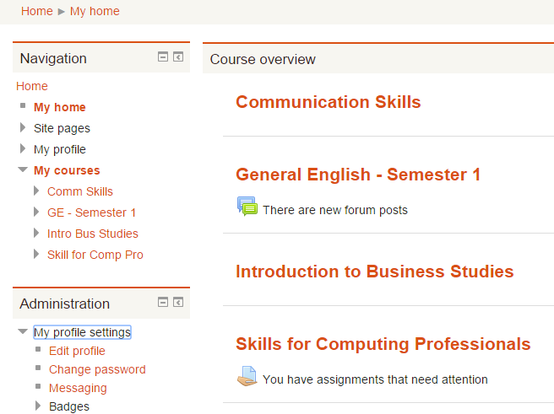

Step Three: Click “Grades” then click “Overview report” in the new window.
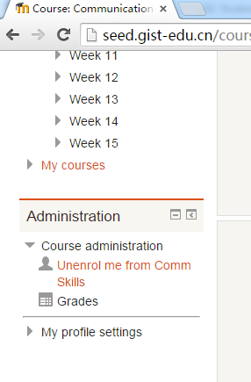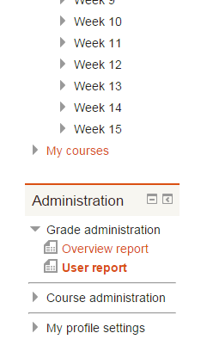

You will then be able to see your results.
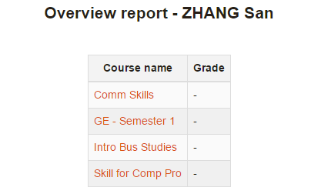
SU Programme Passing Grade: 40 and above
HND Programme Passing Grade: P, M, D
GIST Programme Passing Grade: 60 and above
Important Note: Students MUST enroll into their courses before the end of each semester otherwise their exam results cannot be accessed during the Holiday.

Module Evaluation - Student Feedback at SeED
ALL students are required to provide feedback for each course every semester. The feedback system will be activated in week 13 and week 14. Follow these steps to complete the Course Feedback on SeED:
Step One: Enroll “All Feedbacks” Course
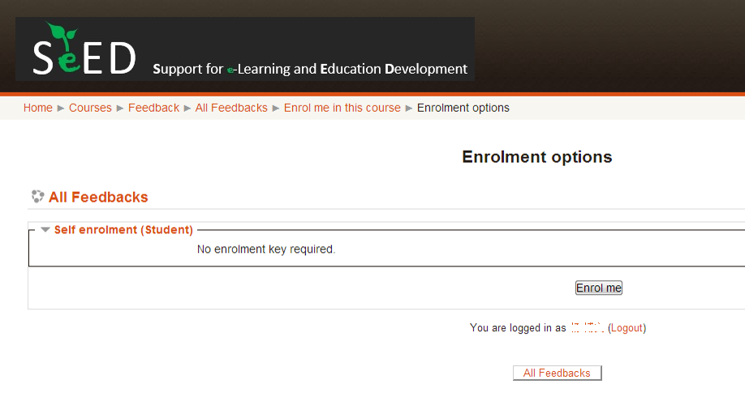
Step Two: Go to your programme and click the course
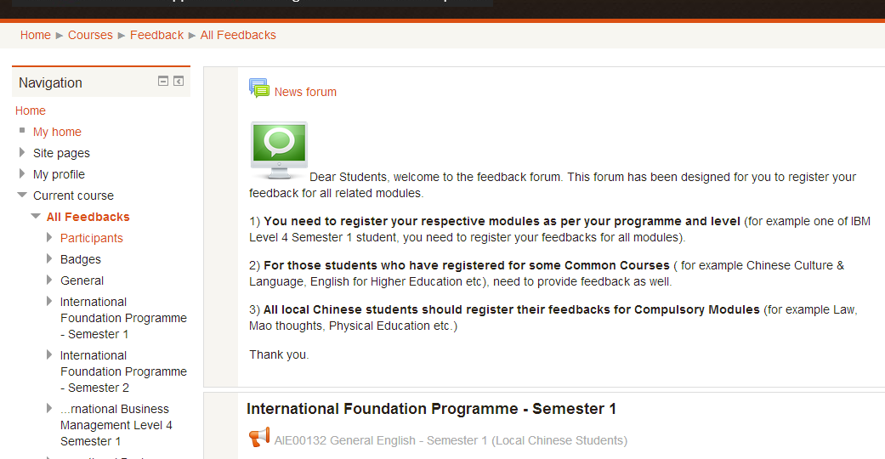
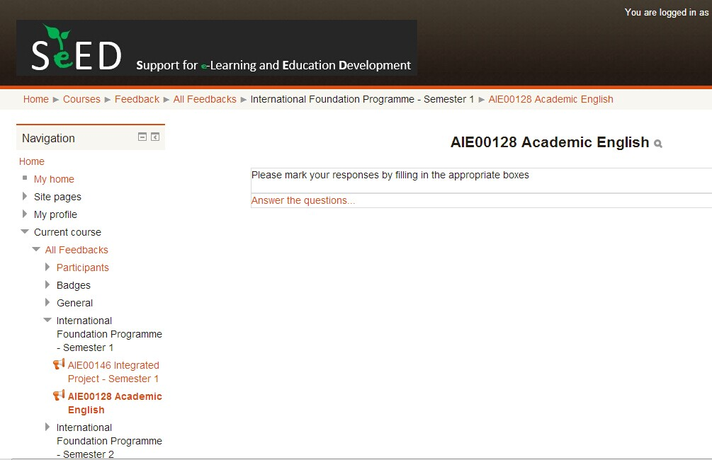
Step Three: fill in your answers for each module
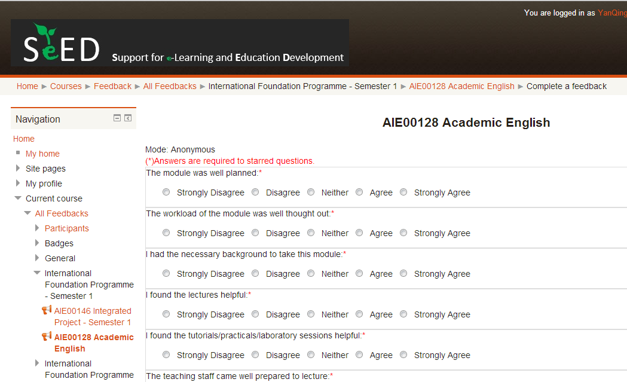
Step Four: click “submit your answers” once you finish the feedbacks.
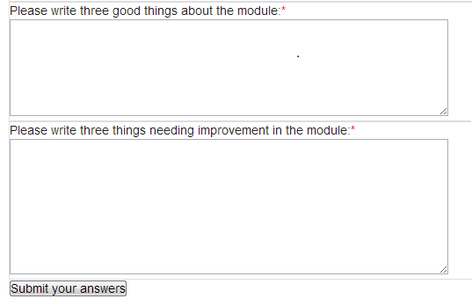
Should you answer the feedback question for other modules, restart from step two.

Assignment Submission

All assignments are to be submitted to the Academic Office, NOT directly to the teachers. Students will need to submit an electronic copy and a printed copy for each assignment. The Academic Office will then issue a receipt to the student.
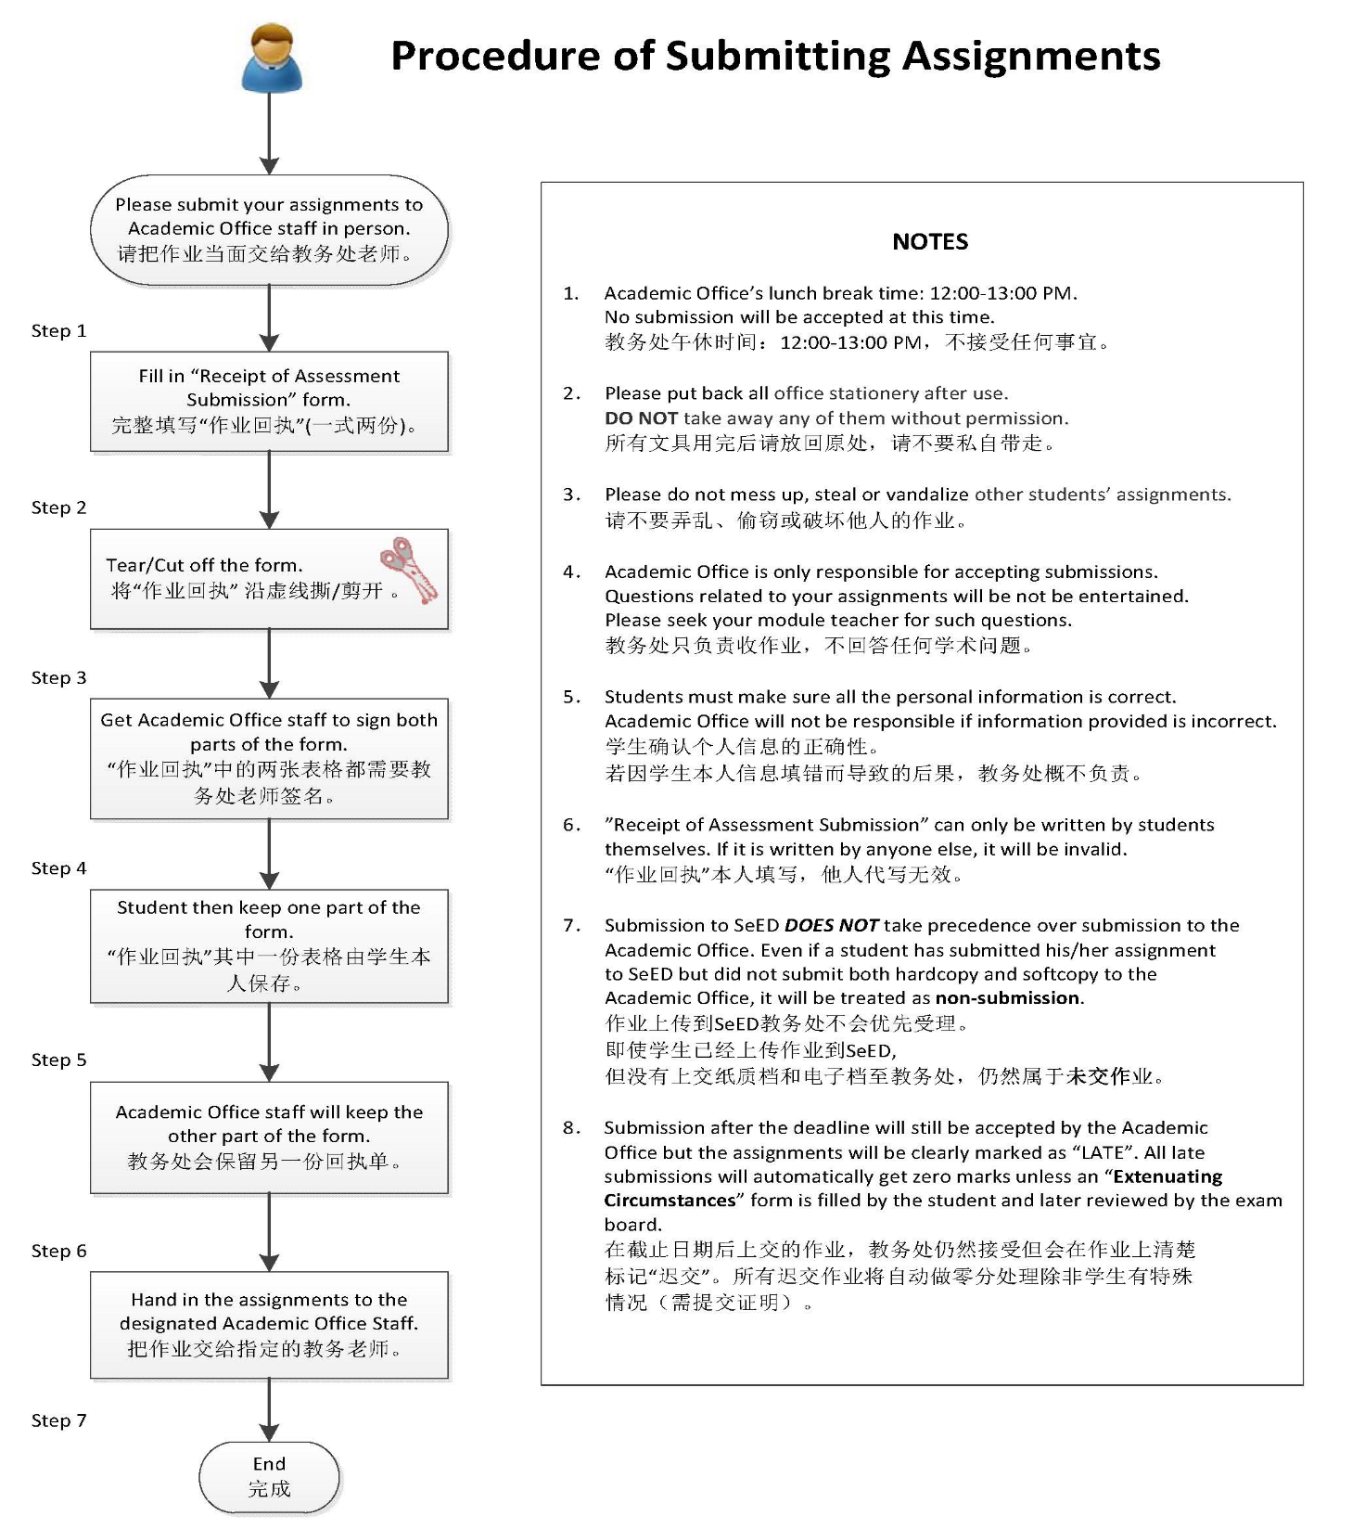
What if I am unable to meet the submission deadline for my coursework?
We recognise that there may be times when you are unable to meet the submission deadline for your work due to circumstances beyond your control, e.g. illnesses or personal difficulties. If you find yourself in such a position you can make a claim for extenuating circumstances.
You are responsible for ensuring that your property is kept safe and secure at all times and for taking out adequate insurance to cover its loss.
We all face the risk (albeit very slight) of having our work, assignments, projects et cetera stolen or damaged as a result of burglaries or by virus attack on personal computers.
Damage to your work prior to its submission is, normally, not regarded as an acceptable explanation for the submission of late or partial work for the purpose of formal assessment in this University.

How is my work assessed?

You may be assessed by a combination of coursework, examinations and your final dissertation (other awards will have practical assessments and Design Shows etc.). Assessments vary from course to course and you may also have to keep portfolios and other documents. Your Course Handbook will explain how your particular award will be assessed, so make sure you understand what is required of you and when.

Progression to the next level of your Award

In order for you to continue to the next level of your award, you will be required to pass the necessary number of credits for each level of your study.
If a placement is a compulsory part of your award, you will normally be expected to pass the placement before you can progress to the next level of your award.
If you are studying the fast-track route of an Honours Degree, please refer to your Course Handbook for specific progression requirements.
Please refer to the relevant section of your Course Handbook or see Regulations.

What if I fail a module?

If you have failed a module you need to speak with the module tutor to get feedback on your result.
Provided you have engaged in your studies and completed all your assessments, you are allowed 2 attempts at any one module (i.e. the original attempt and one retrieval opportunity). Therefore, you must submit the first attempt of the assessment to be allowed a second attempt. Please note that you should attempt all elements of an assessment in all modules.
The Progress Review and Award Boards will set the date by which you are required to retrieve the failed module. You will receive notification of relevant dates from the Information Points when you are contacted about your results and any referral recommendations.
Academic Office will inform students who need to undertake their referrals via SeED ONLY. It is your responsibility to be aware of the referral dates and return to the College in time for your referrals. The academic policy is very strict in which any student who did not take his/her referral will not be considered for a possible 3rd attempt and thus deemed to have failed the module. Student with a failed module may not be allowed to progress to the next semester and may need to retake the entire module by attending classes for one more semester and paying the appropriate fees. There is also a possibility that you may be denied the opportunity for a retake and will be deemed to have failed the award. Therefore it is extremely important that you return to College to take your referrals.
Rules & Regulations for Referral and Retake of Failed Modules
Referrals
- Students are allowed ONE FREE referral for each failed module during the designated referral dates.
- The corresponding course grade will be recorded as “N” if a student is absent for a certain course examination/assignment. Please note that the Assessment/Award Board has full discretion on whether students are allowed to take their referrals.
- All referral dates are set during Winter/Summer holiday and will be posted on SeED. It is the students’ responsibility to check SeED and return to College in time for their referrals otherwise his/her absence will be recorded. Claims of not being aware of referral dates are totally unacceptable as notices are posted on SeED where students are able to access at any place and at any time.
- If a non-submission/absence is recorded for a referral, an “N” will be marked in the student transcript. The Assessment/Award Board will then decide on whether the student is able to refer/resit for a second time otherwise he/she will need to retake the entire module by attending classes.
- The maximum mark awarded for successfully completing a referred element of an assessment will be a pass grade only (i.e. “40R” for SU Programme, “P” for HND Programme and “60 marks” for GIST Programme).
- With regards to Article 1, students who failed to attend their referrals during the designated referral dates will be charged a fee should he/she be granted a referral at another date and time. Also should a student failed his first referral and is later granted another referral by the Assessment/Award Board, a referral fee will thus be charged. This referral fee will be based on the credits for the referred module, i.e. RMB30 per credit for HND programme, RMB20 per credit for SU programme and RMB20 per credit for other programs.
Retake
- The Assessment/Award Board’s decisions on referrals, retakes or withdrawing from the current award are final.
- Students who retake a module will need to attend classes as usual during an academic semester. He/she will need to pay the appropriate tuition fee for the retake module.
- The maximum mark awarded for successfully completing a retake module will be a pass grade only based on each programme’s academic regulations.
- Tuition fee for a retake module will be pro-rated based on either full-time or part-time tuition fee charged for an academic year. All fees are to be paid prior to enrollment into the programme.
- The College reserve the right to update the regulations without prior notice.

Compensation (SU programme ONLY)
Compensation is the awarding of credits for a failed module if you have demonstrated elsewhere in your modules your ability to satisfy the learning outcomes of your award level.
An overall mark of 0-29% or N (a non-submission) for an undergraduate module may not be compensated. An overall mark of of 0-39% or N (a non-submission) for a postgraduate module may not be compensated.
The number of credits that may be compensated within an award will vary depending on the size of the award. A maximum of 30 credits may be awarded a compensated pass at each of Award Levels 4, 5 and 6. Full details will be found in Part 3 of the academic regulations relating to specific kinds of award.
The Award Board has the discretion to determine whether or not to award a Compensated Pass using the criteria outlined in this section. No more than 30 credits at any one award Level can be awarded a Compensated Pass. The Level 6 Award Board may award a Compensated Pass to module failures remaining at lower levels, provided that the total number of credits compensated in the award overall does not exceed 90 and the original mark was 30% or above.
As an exception, the Award Board may refer to your previous attempt in determining the operation of compensation but only in cases where you have made an attempt at the reassessment. This decision is entirely at the Award Board’s discretion and will be considered on a case by case basis. Alternatively, the Award Board may require the module to be retaken.

Academic Misconduct
Academic misconduct is another term for cheating. Cheating is not tolerated at UK universities. As tutors get to know you and your work, cheating is easily detected. Even if you break the rules by accident, it is still treated as academic misconduct, and you will be punished. It is quite common for those who are caught cheating to fail the module involved.
Academic misconduct is defined as an attempt by a student to gain an unfair advantage in any assessment.
You are responsible for protecting your work by taking appropriate precautionary counter-measures such as creating multiple, back-up, hard and soft copies as you work on assessment tasks, and storing them in more than one physical location.
Examples of academic misconduct include, although this is not an exhaustive list, the following:
- Aiding and abetting a student in any form of dishonest practice.
- Bribery: paying or offering inducements to another person to obtain an advance copy of an unseen examination or test paper or to obtain a copy of a coursework assignment in advance of its distribution to the students concerned.
- Collusion: where two or more students collaborate to produce a piece of work which is then submitted as though it was an individual student’s own work.
- Commissioning another person to complete an assignment which is then submitted as your own work or making your work available for commissioning, whether or not for monetary or other gain.
- Computer fraud: the use of the material of another person stored electronically as if it were your own.
- Duplication: the inclusion in coursework of any material which is identical or similar to material which has already been submitted for any other assessment within the University or elsewhere, for example submitting the same piece of coursework for two different modules.
- False declarations in order to receive special consideration by an Assessment/Award Board.
- Falsification of data, for example, the presentation of data in projects or laboratory reports, based on work purported to have been carried out by the student which have, in fact, been invented by the student or altered or copied or obtained by other unfair means.
- Misconduct in examinations or tests, such as:
    - taking cribs, notes or other unauthorised material (including electronic devices) concealed in any manner into an examination or test, whether or not they could be used to gain advantage and whether used or not;
    - obtaining an advance copy of an ‘unseen’ written examination or test paper;
    - communicating or trying to communicate in any way with another student during an examination or test;
    - copying or attempting to copy from another student sitting the same examination or test;
    - being party to impersonation, where another person sits an examination or test in the place of the actual student or a student is knowingly impersonated by another;
    - leaving the examination or test venue to refer to concealed notes;
    - taking away rough notes, stationery, scripts or examination or test papers which indicate that they are not to be removed from the examination or test venue;
    - continuing to write after the invigilator has announced the end of the examination period.
- Plagiarism is defined as the representation of another person’s work, without acknowledgement of the source, as the student’s own for the purposes of satisfying formal assessment requirements. Examples of plagiarism include (this is not exhaustive):
- the use in a student’s own work of more than a single phrase from another person’s work, without the use of quotation marks and acknowledgement of the source;
- the use of ideas or intellectual data of another person without acknowledgement of the source, or the submission or presentation of work as if it were the student’s own, which are substantially the ideas or intellectual data of another person;
- copying the work of another person;
- the submission of work, as if it were the student’s own, which has been obtained from the Internet or any other form of information technology;
- the submission of coursework making significant use of unattributed digital images such as graphs, tables, photographs etc. taken from books/articles, the Internet or from the work of another person;
- allowing or being involved in allowing, either knowingly or unknowingly, another student to copy another’s work, including physical or digital images.
THE ABOVE LIST IS NOT EXHAUSTIVE AND SHOULD NOT BE INTERPRETED AS SUCH BY STUDENTS.

Extenuating Circumstance
An “Extenuating Circumstance” is something unexpected that gets in the way of your studies. The Extenuating Circumstance form lets us take this sort of event into account. If something happens that stops you learning as well as you can, use this form. If something stops you from doing any of your course assessments (including examinations) as well as you can, use this form.
There are some things we usually do not accept as Extenuating Circumstances. These are:
  - Holidays.
  - Lateness due to traffic problems.
  - Money problems.
  - Claims that you did not know hand-in or exam dates or times.
  - Personal computer and printer problems. (See below).
  - Handing work in late on the due date.
  - Cases where your medical evidence is about a different period of time.
  - Cases where you do not give us any evidence (medical or otherwise).
  - If you could have foreseen, avoided or prevented the problem.
  - Minor illness or accident.
  - Late submission if the work is more than ten Working Days late (this would be “Non-submission”).
  - Poor time planning or poor time management.
  - Poor or careless practice (e.g. no computer back-ups).
When you fill in the Extenuating Circumstances form, you must give us evidence with your claim. We will not search for evidence – you must hand in whatever evidence you want us to look at. What is appropriate evidence is different in every case. If you need to give us a full medical report or letter, you may have to pay your doctor to provide this.
We need more than just your own statement of your circumstances to prove you have been ill; you cannot “self-certificate” for late submission or non-submission of work. A full medical report from your Doctor will be needed.
Do not use the Extenuating Circumstances form if you have missed a seminar, lecture or lab work because of illness but will be able to catch up on work and hand it in on time. You need to let us know if you cannot attend because of illness.
If you join a course after it has already begun (e.g. part-way through the year), this will not be an extenuating circumstance.
Once you submit a claim for extenuating circumstances, you have to:
- If you are claiming “Mitigation” you should hand in your work by the original deadline.
- If you are claiming for “Late Submission” you should hand in your work as soon as you can but within 5 Working Days of the original deadline.
- If you do not submit the work, your claim would be for “Non-submission”.
A “Working Day” is classed as Monday to Friday (except public holidays). The Extenuating Circumstances Panel will make a decision based on when your extenuating circumstances happened and the date when you submitted your work.
Remember: a claim based on a minor illness (for example, a cold) will fail. Unless you see your Doctor or Counsellor when you are ill or having a problem, your Extenuating Circumstances claim will probably fail. We need to be sure when things that affected your course happened. The dates in your evidence should match the dates you are telling us about.
A claim will usually fail if it has no appropriate supporting evidence. Think about what happened and who knew about this: try to find an independent person, organisation or support service that could write a letter (or fill in Part B of the form) and tell us what happened. A member of University staff may be able to do this if you spoke with them when the problem was happening.
If your claim is claim is upheld/supported, you will not be given a higher grade as a result of a successful claim. It will allow late submission, or to give you another chance to do your best work, if your situation makes this the right thing to do.
- If a claim for Non-submission is upheld (i.e. successful), you will be allowed a new chance at that work as if the deadline you missed had never happened.
- If a claim for Late submission is upheld, your work will be marked and counted as if you had handed it in on time.
- If a claim for Mitigation is upheld, you will be told what mark the work got. You can then choose whether to accept that mark or try again if you feel you could improve the mark by doing the assessment again.
If you want more detailed information, see your Award Handbook or http://www.staffs.ac.uk/support_depts/info_centre/handbook/extenuating/. If you are claiming for mitigation or non submission/non attendance, your new submission date will be set by the next Award Board and you will be notified of this in your results letter, following the relevant Award Board.

How do I work out which Classification I will receive?

In order to be considered for a degree, the Award Board considers whether you have met the credit requirements for your award and will award you the appropriate classification. In certain circumstances, the Award Board can award you a higher classification, depending upon your performance at level 6 modules.
Please refer to your Course Handbook or Award Regulations for further information on determining your degree classification.
Grading System (SU Programme)
Percentage Range | Associated Honours Classification
70-100% | First Class
60-69% | Second Class (upper division)
50-59% | Second Class (lower division)
40-49% | Third Class
30-39% | Fail which may be compensated
0-29% | Fail which cannot be compensated  A minimum mark of 20% must be achieved in each element of assessment in order for a module to be passed overall.*
N | Fail due to non-submission which cannot be compensated. No further attempt allowed.
* All Staffordshire University modules are assessed with a Percentage Mark Scale system. Some modules may specify that a higher minimum percentage is required in each element of assessment in order for an overall pass in that module. Where this is the case, it will be stated on the module descriptor.

Fees
- Tuition fees
Tuition fees are payable in full, at enrolment each semester/year, unless acceptable instalment or payment arrangements have been agreed with Financial Services.
      - Accounts will become due on the dates specified in the invoice/College Notices.
      - Where an account remains overdue after the due date, a series of reminder will be sent via SeED. The relevant Faculty will be notified of the tuition fee and make contact with the student to resolve the situation.
      - Following this, a final warning will be post on SeED and Notice Board notifying the student of their exclusion from the University.
      - The University will refer all outstanding accounts for tuition fees to its external debt recovery agents for appropriate legal action to recover the debt. This may incur additional charges being added to your account and ultimately affect your ability to obtain credit in the future.
      - If a debt on the tuition fee is outstanding, coursework, examination and other assessments will not be considered by Award Boards. If the debt remains outstanding at the end of the academic year, the student will not be allowed to graduate or re-enroll at the University until the account is cleared.
      - Where a student has made an agreement to pay their tuition fee account by instalments but has defaulted; then these credit control procedures will commence immediately after the initial default whereby the whole debt will then be due in full.
Finance Department will send invoices to ALL international students each semester via email. If you did not receive your invoice, please contact Finance Office’s Ms. Hui YU (refer to “Contacts”). You are advised to pay your fees by the due date as stated in the invoice. We would like to remind you that any late fee will be subjected to a penalty of 5% per month with immediate effect.
All fees are to be paid in US dollars (USD) except for University Fee, which is quoted in Sterling Pounds (GBP). Any conversion must be based on these two currencies only. New applicants must pay the International Registration Fee in full and 50% of their first semester's tuition fee in order to have their visa processed.
Please take note of our Hong Kong HSBC account details (for International Students ONLY) below:
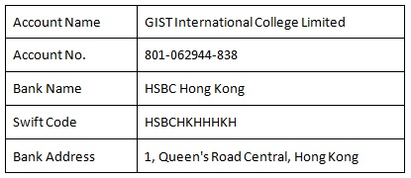
ICBC account details (for Local Chinese Students ONLY):
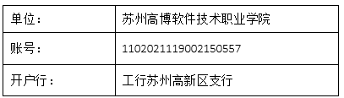
You are required to pay for all transaction fees levied by your home country’s bank (the paying account). Therefore please ensure that these amount paid will include the transaction fees levied by your bank. Please include your name and your GIC student ID when remitting your tuition fees.
To confirm your payment of fees, please forward a scanned copy of the bank-in slips to our Finance Office’s Ms. Hui YU (refer to “Contacts”) as proof of payment.
In addition to the payment of tuition fees, some courses also require the payment of a registration, Residential and Visa Renewal Fees and/or examination fee at the same time. Payment should be made as soon as requested by the University. Such fees are sent directly to external awarding bodies by the University on your behalf and are non-returnable.
For any direct cash payment to our Finance Office in China, please ensure that you have converted your cash to Chinese Renminbi (RMB/CNY) beforehand. Finance Office will not accept any other currencies.
- Repeat / Referral Fees
Full-time and part-time students repeating a module(s) with attendance (or the distance learning equivalent), studying a replacement module or returning from intermission, will be charged an additional tuition fee based on the number of credits being undertaken unless they have had extenuating circumstances accepted by the University for the failed credits. The fee will be pro-rata that of the full-time/part-time rate fees charged in the year and will be payable on enrolment.
Referral fees- RMB30/credit for HND programme, RMB20/credits for SU and GIST programme.

Resource Room & DuShu Lake Library
Our resource room is located on the 3rd floor. Should students be deemed liable for any damage books, articles or facilities in the Resource Room, you will be required to pay for a new replacement. Failure to do so may result in your exam results being withheld by the College.
Each student may apply for a library card to borrow international books from DuShu Lake Library, which is a community library. Our Student Services staff will help you with your application but you are required to pay for any charges or deposit levied by the library.
Learning & Resource Centre General Rules and Regulations
Opening Hours
Please refer to Schedule Posted on the Entrance.
All books are for reading in the Resource Center, NO BORROWING BOOKS.
Prohibited Behaviors in the Resource Center
- Bags, electronic equipment and personal property should not be left unattended. For security reasons, items may be removed. The library is not responsible for theft or damage of personal property.
- Smoking or electronic cigarettes are not permitted in Information Services buildings. Cold food and hot and cold drinks are permitted; however, hot food is not allowed in any area of Information Services. Anybody consuming hot food will be asked to leave. The use of mobile phone is permitted in group study areas only.
- Books and other materials available for loan or consultation within the Library must be treated with care at all times. Payment may be required for any item which is damaged.
- When leaving the Resource Center, students are required to produce for inspection all books and items taken out of the Resource Center.
- Reservation of seats is not permitted. Books and other articles left for any length of time on chairs and tables may be removed by the Resource Center staff.
- Students must be decently dressed and conduct themselves properly in the Resource Center.
- The Resource Center is only opened to the students and staff of GIST International College (GIC). Strictly no outsiders are allowed without prior written consent from the management.
Computer Usage Rules
- Do not use the computers to do the following:
- Playing Games
- Playing Videos
- Playing Music
- Accessing Forbidden/ Malicious/ Pornographic/ Unethical Websites
- Do not install or uninstall any program or service in any computer. This is the responsibility of the Resource Center/ IT staff. Report the matter to them where necessary.
- If any device or the computer is not working, do not fix it. Kindly report to the Resource Center staff immediately.
- You are allowed to use the computer for a time allocated by the Resource Center staff. If need be, you may be asked to give others opportunity to use the computer.

Student Club Executive Committee (SCEC)
- General Provisions of Student Club Executive Committee (SCEC)
The Student Club Executive Committee (SCEC) is a joint committee of both the international and local Chinese students at GIST International College. It acts as a liaison between the student body and the school administration. The Executive Committee takes orders from Student Service Department (SSD) and advocates on behalf of student groups (clubs) to gain resources for student groups' benefit, allocates resources among student groups (clubs), and arbitrates among student groups (clubs) and any other involved parties. The GIC committee’s mandate is to work on goals and initiatives that benefit the school and the students.
- Support/Arbitration
The SCEC is responsible for arbitrating among student clubs and offering support for student clubs issues. In the event of a conflict, dispute, or disagreement between student groups with clubs, the SCEC can be approached as a source of mediation and assistance in communication. Similarly, if a group feels strongly about any given issue, whether it be one involving other groups, other clubs/departments at GIC, or other colleges/universities, such a group is perfectly justified in seeking support from the SCEC. Depending on the nature of the issue at hand, the SCEC may or may not work with Student Life Programs to develop a solution. While the students who serve on the SCEC may consult with and be advised by the SSD, decisions affecting student clubs or student activity at GIC are made by the SSD and Registrar. If student groups are unsatisfied with the SCEC’s decision or opinion, they may appeal to the SCEC to reconsider the situation. If this is still unsatisfactory, they may bring the matter to the SSD.
Student Groups or clubs should feel free to contact the SCEC Executive Board if they are looking for support and/or arbitration on an issue. An appeal to the SCEC consists of an email from a leader of a student group/club explaining in detail the reason for the appeal and the justification for reconsideration by the SCEC.
- SCEC Members
The SCEC is a board made up of 5 international students and 5 Chinese students, who are listed below along with their positions (Duke ZHANG is in charge of international students now). There are no members of the faculty or administration in the SCEC.
With the exception of the SSD Representatives, all positions are elected positions. They are elected by student groups at SCEC meetings. The SSD (international student service and local Chinese student service) representatives are appointed by the GIC President and registrar, respectively. If you are interested in participating or contributing to students groups or the SCEC, please feel free to contact the SSD for more information.
- 2012-2013 SCEC Organizational Structure

All SCEC Executive Board members have shared responsibilities to carry out the GIC activities, which involve organizing collective resources for student groups in-charge of activities midways, the first-year students orientation, bulletin board space, and SSD office space (activity and club equipment) et cetera; processing new club applications; voting on rule enforcement; and representing student activities in meetings with members.
Additionally, the SCEC President, Treasurer, Secretary, PR, and Club Activity Affair have special responsibilities:
Position | Responsibility
President | - Work with the student clubs and school activity management and assist SSD towards building a greater and stronger SCEC in GIC.  - Chair weekly SCEC meetings and set overall direction. The SCEC President is the head of the organization, serving as the primary representative to students, leading executive board meetings and setting the agenda for discussion.  - Support and help SSD to judge all clubs in the implementation of club and school activities.  - Take lead in all clubs and activity committee initiatives in adherence to community values.
Secretary | - Take charge of scheduling meetings; arranging meetings, translating during meetings, taking minutes of meetings, and collecting documentation from leadership of clubs and SSD.  - Assist the President in dealing with daily issues.
Treasurer | - To allocate, control and monitor use of resources, school budget, club fee, membership fee, sponsor fee from clubs and activities (cash or e-transfers) in efficient and effective ways. Report to president via both softcopy and hardcopy weekly.  - Collect club budgets and prepare student activity budget at the beginning of every semester. Collect a bi-annual financial statement both from clubs and SCEC at the end of every semester.  - Prepare and finalize the annual Student Committee budget based on the Student Committee President’s vision. Any club that collects any club fee or membership fee must have a document (hardcopy and softcopy) approved by SCEC and SSD signature, and SCEC president signature.  - Monitor individual Student Club’s expenditures through the monthly reimbursement process and submit claims for SSD review and approval.  - Responsibility of overseeing students’ ventures and allocating profits to designated student initiatives.
Club and Activity Affair Department (CAA) | - Monitor and help all the club and school activities.  - Plan and hold club elections and transition.  - Maintain and update monthly club and campus activity calendar with upcoming events in Suzhou with club presidents and SSD office.  - Closely monitor the effectiveness of CAA events and document the progress.  - Plan school activity and hold events together with SSD.
Public Relationship Department (PR) | - Pay close attention to the effectiveness of club events, school activities and document the progress for future promotions. Work along with the student clubs and deliver social activities to the student throughout the year.  - Explore external partnership opportunities for the school and clubs.  - Manage GIC student’s participation in the area Competition. Work with all participants to support Internal Competitions. Co-ordinate with the SSD and clubs to initiate fund raising services, (e.g.: looking for sponsors, marketing promotion etc.).
- Elections
Regular elections will occur at the Wednesday School Meeting.
The main topic for the 1st SCEC Meeting is election of the 2012-2013 years Executive Board. Please consider running for election. In order to effectively govern and advocate for GIC student groups, the SCEC executive board is comprised of GIC’s current SSD and AO who understand the needs and challenges of running a student activity organization.
- Positions
The following positions will be elected in this order:
- President
- Treasurer
- Secretary
- Club and Activity Affair Department (CAA) --Leader
- Public Relationship Department (PR) --Leader
- Electoral Process
First Round:
- The Board is elected by the GIC students (5 members will be chosen by local new students, 5 members will be chosen by International students), with each voter eligible for one vote (though a single person only receives one vote but you should write 5 nominations on a voting paper).
- Then Joyce will calculate the number of votes on the spot.
- SSD leader will announce the TOP 10 nominated people and write on the white board and these 10 persons will give a speech in front of everyone within 3 minutes.
Second Round:
- After the 10 nominated persons finish their speech, voters will nominate 5 suitable persons for the 5 job positions in SCEC.
- Then Joyce will calculate the amount of votes on the spot.
- SSD leader will announce the final result of the election and write it on the white board. (If there is a tie for the same position, a question related to the position will be asked to the two candidates by the SSD representative, and based on the candidates’ answers, another round of election will be held.)
-END OF ELECTORAL PROCESS-
- Acceptance of Position
- SCEC 5 members will read and submit their contracts with their signatures approved by GIC’s SSD and AO after the Meeting.
- After acceptance of the position, official list of SCEC executive committee will be displayed on SEED and SSD notice board.
- GIC will only recognize a leader’s position after that member has signed the official document approved by GIC’s SSD and AO.

Accommodation
The apartment’s management requires that each student pays the one-month deposit with cash. You will be issued a receipt whereby you only need to return this receipt directly to the apartment’s front desk for your refund after you had completed your stay with them. Therefore please ensure that you bring enough cash with you to pay for your one-month deposit.
Please also note that if you had booked a 2-bedroom or 3-bedroom apartment, it is on a first-come-first-serve basis. In the rare circumstances that we are unable to find a room-mate to share your apartment, you may need to pay for the entire apartment or select other options.
Current international students (who have completed at least one semester at GIC) are advised to arrange for their own accommodation for the new semester before leaving for semester break. Please work out who your new room-mates will be, then talk to the apartments’ management office to secure your apartment for the new semester otherwise you may not have a place to stay when you return from your break. Student Services staff will facilitate but you will need to book and pay for the accommodation directly to the apartments’ management office. Please remember to inform Student Services staff of any change to your residence.
New intake international students are to fill up the “Student Accommodation Release Form”(see Appendix C) after three (3) months staying in their apartments. Please DO NOT simply check out of your existing apartments during the holiday. Should you check out, there is a high possibility that you will not find other apartments when you return for the next semester.
All international students must pay for their own accommodations on time directly to the apartment’s front desk to reserve their accommodations prior to leaving for their holidays.
Accommodation Rules and Regulations
The accommodation terms are as follow:
  - Living in Dormitory: The one-year rental must be paid in advance. The following year’s rent should be paid 2 weeks before commencement of the new contract. Non-payment will result in immediate eviction from the rented property and the College will NOT be responsible for such consequence.
  - Living in Apartment: Rental must be paid every quarter (for 3 months). The College is only responsible for collecting and paying on your behalf the first quarter of your study in China. You will need to pay in cash a one-month rent deposit to the apartment’s front desk. This deposit is refundable upon returning the deposit slip and checking out of the accommodation at the end of the tenancy. For subsequent quarters, you will need to pay directly to the apartment’s front desk and possibly work out whom your room-mates will be. Non-payment will result in immediate eviction from the rented property and the College will NOT be responsible for such consequence.
  - Students are NOT ALLOWED to change or withdraw from the assigned dormitory/apartment within the period of stay when your accommodation is managed by the College, i.e. collecting and paying rent on your behalf. Should you decide to do so, your one-month rent deposit may be forfeited by the apartment’s management for inconvenience caused to your existing room-mates and the College.
- Upon moving into your dormitory/apartment, students must deposit utility money into an account (provided by the property management office) for utility bills’ deduction, i.e. water and electricity. When your deposit is running low, you will be notified by the staff of the dormitory/apartment. You will then need to top-up your deposit in order to continue using the water and electricity.
- You are responsible for the cleanliness of your dormitory/apartment – both inside and outside – as well as proper usage and care of the furniture and electrical appliances that come with the dormitory/apartment. Any complaints received from the property management office will be dealt with in a strict but fair manner. You will lose your one-month rent deposit and any rental paid should you breach this rule.
- The College will not be held responsible for loss, damage or theft of your personal or private belongings at the dormitory/apartment.
- You should at all times conduct yourself in a proper manner. Refrain from using obscene or unpleasant language and make every effort to avoid making a ruckus in the accommodation and disturbing the peace of the neighborhood.
- You should always show respect and consideration for your roommates.
- You must not share a room with the opposite sex which may affect your good name and that of the College. Should such an indiscretion occurs, the College will take steps to notify your parents/guardians and may bar you from continuing your studies.
- No drugs or any illegal substance are allowed in the dormitory/apartment.
- Students must refrain from getting into physical altercations (fights). Students found fighting will immediately be evicted, and the police will be called in to handle the situation.
Changing Accommodation
- Guidelines to changing accommodation are as follow:
- Living in Dormitory: After the one-year contract is completed without any problems or complaints raised, students can apply to withdraw from the accommodation arranged by the College.
- Living in Apartment: After the quarter (3 months) contract is completed without any problems or complaints raised, students can apply to withdraw from the accommodation arranged by the College. However please note that your tenancy agreement is for one year and thus the daily rate quoted is based on this agreement. Should you move out in less than one year, the apartment’s management will levy a higher daily rate for which you must then pay the difference.
- To withdraw, you must notify the Student Services Department ONE MONTH before the contract expires. Late notification will result in a fine of RMB 200.
- Please ensure that you have found a new accommodation prior to moving out and preferably before the contract with the College expires.
One-Month Rent Deposit for Those Living in Apartments
- Effective September 2013, students are expected to pay their own rent deposit (in cash) to the front desk, thus those who did so will only need to request for refund from the front desk when checking out.
- However for students who had previously paid deposit via the College, you will need to return the keys to your dormitory/apartment to the property management office. You will also need to clear any outstanding utility bills and pay for any damages caused to the furnishings and electrical appliances. Finally you will need to provide the receipt of the accommodation deposit in order to get your full refund. Payment of your deposit will be made within TWO MONTHS from the date of withdrawal.
IMPORTANT NOTE: Should you choose to arrange for your own accommodation, GIST International College will not be responsible for any issues or risks associated with your new living arrangements.

Health Insurance
Please note that all foreign students coming to China for their studies MUST have health insurance. Students MUST purchase a health insurance back in China. Please also note that any additional cost incurred in the application of insurance will need to be borne by the parents/students. The most basic insurance package in China starts at RMB 550 (USD 90), covering accidents and hospitalization in China. Students with no insurance are NOT ALLOWED to proceed with their studies.
Health Insurance Plan:
To be filled by SSD

Visa and Residence Permit (International Students ONLY)
According to the People Republic of China’s rules and regulations, foreigner with expired visa will be fined RMB 500 per day, up to a maximum RMB 5,000 by the Chinese authorities. The College will not be responsible for any fine levied as international students must be very well aware of their visa’s and/or residence permit’s expiry dates and be responsible to have his/her visa renewed (facilitated by Student Services staff).
Students already enrolled in our programme must pay their annual visa renewal fee of USD 90 at least 3 weeks before the visa expires otherwise the visa may not be renewed on time. This fee covers visa processing and mandatory one-year health insurance only. Resident permit fee (about USD 130) due to the local authorities will be borne by students themselves.
Please also remember to visit the police station to register for temporary residence within 24 hours upon returning to China otherwise you may be fined RMB 50 per day, up to a maximum of RMB 2,000 by the Chinese authorities.

Appendixes

Appendix A
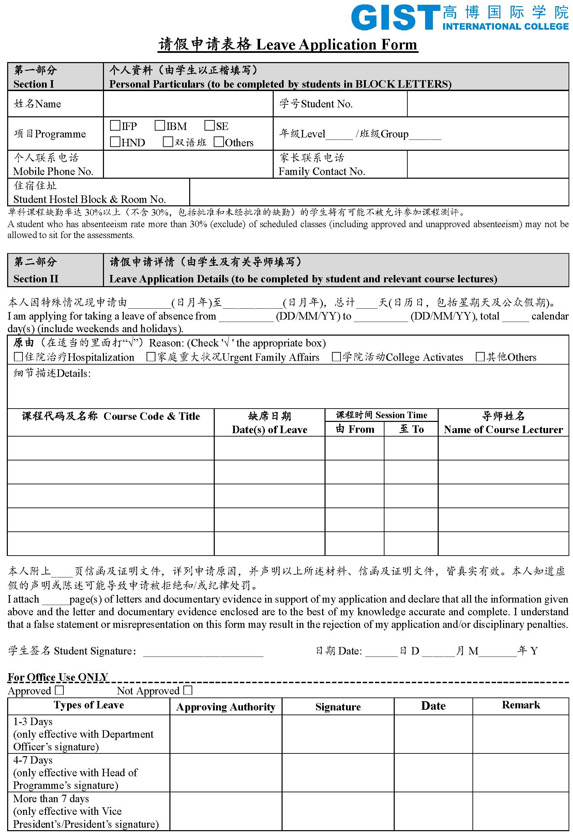
Appendix B

EXTENUATING CIRCUMSTANCES claim form 2015/16
Part A
Please use BLOCK CAPITALS for this section.
You must fill in this part of the form. Cut along the line on the opposite page and staple the flap to the left of this page before you hand it in.
First name:  Surname: | Student Number | Course title | Faculty/School
Address (the Panel’s decision will be sent to the address you write here)
 |  |  | Postcode
Contact Telephone Number |  | Email
I confirm that to the best of my knowledge the information given on this form is a true and accurate statement of my personal circumstances.  I understand that details of this claim will remain confidential to any panel considering your claim. |  |  | Your Signature
 |  |  | Date
Part A-1
Use this box to tell us what happened and how it affected your work. Use this section only - do not continue on extra sheets.
CHECKLIST FOR COMPLETION BEFORE HANDING IN THE FORM
- Part A: All of your personal details completed fully
- Part A-1: Details of your circumstances explained
- Part A-2: All relevant supporting evidence attached and /or Part B completed fully (latest drafts of work attached as proof of work completed if required)
- Part A-3: All boxes in the table completed
Please cut along the dotted lines and fold over to conceal your personal details in part A.
Make sure that you have completed all sections before you submit the form.
If you do not fully complete the form and provide evidence as required, your form will be returned to you and will not be processed any further until you return it fully completed.
Check the deadline for submission on the front page and if within the deadline, return this form to the appropriate Faculty/School Office with your evidence.
-----------------------------------------------------------------------------------------------------------------------------------
Part A-2
Do you have supporting letters or documents to prove what you are telling us?  Yes No  Note: Claims will not be successful without any supporting evidence. | If you have ticked “No” and have no documents about what happened, a supporting statement needs to be written in Part B. Depending on what has happened, who witnessed it, and who is best professionally qualified to confirm it, Part B might be completed by a tutor, a member of University support staff, a Counsellor, Faculty Student Guidance Advisor, University Student Guidance Manager or someone from the Students’ Union Student Advice Centre. If your Extenuating Circumstances are about illness, your evidence must be from a Doctor, Nurse, or Hospital. If you are not sure who to ask to complete Part B, get advice from the Students’ Union Advice Centre, Faculty Student Guidance Advisors or the University Student Guidance Manager.
Part B
If you have not included a doctor’s note, a Statement must be completed by your General Practitioner (Doctor), Counsellor or other person suitably qualified such as your personal tutor to provide an opinion/supporting statement on your circumstances.
Name |  | Position
Contact Address
Telephone No. |  | Signature | Date
If the circumstance covers more than one module/course component, part B need only be completed once.  Please provide a brief outline of the extent to which, in your professional judgment, the student was/will be affected by the circumstance and the dates to which his/her circumstances apply. |  |  | Official Stamp
Supporting Statement

For School/Faculty Office Use
Date Considered | Late Submission | upheld | rejected | awaiting student action
 | Non Submission of work/Non Attendance at assessment | upheld | rejected | awaiting student action
 | Mitigating Circumstances | upheld | rejected | awaiting student action
Reasons for Decision

Part A-3
Please indicate AGAINST EACH MODULE you list below the effect of the circumstance that you are claiming for by using the following codes: PLEASE REMEMBER TO LIST ALL MODULES AFFECTED.
“M” is for “Mitigation”. Use this code when you were able to hand your work in on time (or attend the exam) but its quality has been affected by your Extenuating Circumstances.
“L” is for “Late”. Use this code if you need up to 5 extra Working Days in order to hand in your best work because your Extenuating Circumstances have slowed your work down. If you need help in working out when your new submission date will be then please contact your Faculty or Faculty Student Guidance Advisor.
“N” is for “Non-submission” of assignments or “Non-attendance” at assessments/exams. Use this code if you could not attend a test or could not hand in your work as “Late”.
  - Use the grid below to list every assessment your circumstances affected. List each assessment separately.
  - You should note that, where appropriate, you may claim both late submission and mitigation for the same module(s).
  - If something changes after you hand in the form and you need to change the code you used, contact your faculty or School office immediately.
  - Give full and exact details of the assessment you are claiming for. If the affected assessment is one small component of the whole assignment (e.g. portfolio) please make this clear on the form.
Module Code | Credits/CATS Points | Module Title | Assessment Type  (e.g. exam, project etc, state all assessments affected for each module) | Original hand in date(s) | Actual hand in date (important  if you are claiming ‘L’ or ‘M’) | Type of  circumstance

Appendix C

Assignment Hand In Form – Cover Page

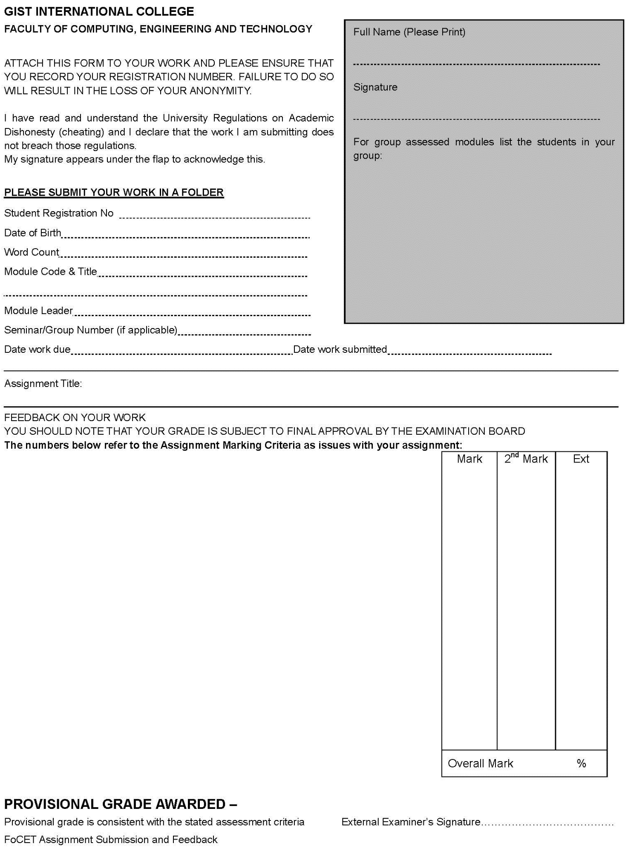
Appendix D
Student Accommodation Release Form

To whomever concern,
GIST International College has clearly briefed me on the safety concerns of moving to an accommodation outside its jurisdiction. I am fully aware of these concerns but have decided, on my own accord without pressure from any party, to move to an accommodation of my own choice.
I hereby declare that I am responsible for my own actions and arrangement and thus will not implicate nor hold GIST International College or Global EduTech Management (SuZhou) responsible for any issues that may arise from this move to an accommodation of my own choice.
Signature of Student,
_____________________________
Student ID:
Full Name:
Passport / IC No.:
Date of Signature:

Appendix E
Elective Module Sign-Up Form

Date: 20____ / M ____ / D ____

Student Name: | Enrolled Programme:  IBM Level _____ IFP Group_____  HND Level _____ Group_____  GIST Year_____ Group_____  SE Level _____ Others: _________________
Student ID:
Module Name:  English For Higher Education (EHE)  Chinese Culture and Language (CCL)  Karaoke Club  English Corner  Others: _______________________ | Reason for Taking the Module:  To improve English proficiency  To improve Chinese proficiency  Others: _______________________
Student Declaration:
Yes, I will sign-up for the recommended module.
No, I am not going to sign-up for the recommended module.
(If you tick ‘no’, please complete the following section).
To whomever concern,

GIST International College has clearly briefed me on taking the recommended module in order to improve my academic performance and study skills. The lecturers and counsellors have also encouraged and motivated me to take the recommended module. However, I have decided not to take the recommended module and will thus be responsible for my decision.

Student Signature: ____________________
Remarks (to be filled by Academic Office staff)

Academic Office Staff Name: |  | Academic Office Staff Role:

